

**MSPM’S**

**Deogiri Institute of Engineering and Management Studies, Aurangabad**

**Department of computer science and engineering**

Servay based report

On

**HP 14q core i3 7th gen**

Submitted By

Name**: Kothalkar Priya**

Roll No: 26037

Under the Guidance of

**Mr.P.Durole sir**

Department of computer science & engineering

(Deogiri Institute of Engineering and Management Studies)

2019-2020



CERTIFICATE

This is to Certify that Miss. **Kothalkar Priya** , Seat No. **26037** has completed a report writing on servay in subject computer Architecture and Organisation.

**Mr.Pankaj durole Prof.SanjayKalyankar Dr.Ulhas Shiurkar**

**Subject Teacher H.O.D. Director**

**HP 14 q core je 7th Gen- ( 4GB/1TB HDD / Windows 10 Home ) 14q - cs laptop (14 inch , smoke gray , 1.55 Kg ,with MS O office)**

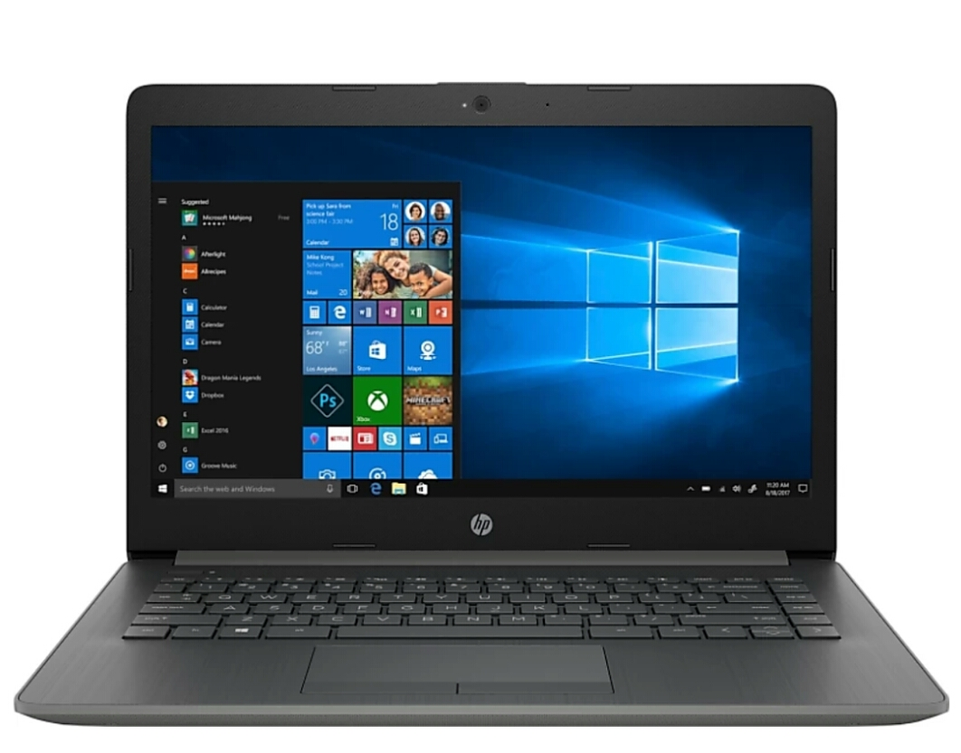

**Key features:**

* Pre- installed genuine windows 10 os .
* Pre- loaded MS office Home and student 2016
* Light laptop without optical disk drive
* 14 inch HD LED back lit Bright view display

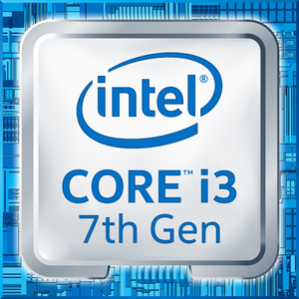

**General**

Model No - 14 q - cs 0014TU

Processor - Intel I3 core 7th Gen

Ram - 4GB

HDD - 1TB

Memory slots - 2 slots

Expandable - hoti 16 GB

RPM - 5400

Graphic processor - Intel integrated

Part no - 7 EF94PA

Series - 14q

Colour - smoke grey

Suitable - Processing & Multitasking

Battery cell - 3

**Memory and processor**

Processor Brand - Intel

Processor Name - Core I3

Generation - 7th generation

Ram - 4GB

Ram type - DDR4

HDD capacity - 1 TB

Processor variant - 7020 U

Clock speed - 2.3 GHz

Memory slots - 2slots

Expandable memory - Upto 16GB

RAM frequency - 2133MHz

Cache- 3 MB

RPM - 5400

Graphic processor - Intel integrated HD 620

No of cores - 2

**Operating system**

OS Architecture - 64 Bit

Operating system - Windows 10 Home

System architecture- 64 Bit

**Port & slot features**

Mic In - Yes

RJ4S - Yes

USB port - 1×USB 2.0 , 2× USB 3.1

HDMI port - 1× HDMI port (v 1.4 )

Multi - card slot - 3 in 1;card reader (SD , SDHC , SDXC)

**Display & Audio features**

Touchscreen - NO

Screen size - 35.56 cm (14 inch)

Screen Resolution - 1366×768 pixel

Screen type - HD LED Backlit bright view display

Speakers - Built in Dual speakers

Internal Mic - Built in Microphones

**Connectivity Features**

Wireless LAN **- IEEE 802**.11a/b/g/n/ac

Bluetooth - V4.2

Ethernet -; Integrated 10/100/1000 Gigabit LAN

**Dimensions**

Dimensions - 334.8× 233.9×19.8 gm

Weight - 1.55Kg

**Additional features**

Disk drive - NOt available

Web camera - VGA webcam

Lock port - Kensington mini security slot

Keyboard - Full Size island-style backlit keyboard

Pointer device - Multi Gesture Touchpad

Recovery options - recovery manager installer for windows 10

Included software - HP Audio switch, HP jump start , HP support assistant , microsoft office Home & Student 2019

Additional features - Li-on battery , Miracast certified

**Processor Architecture:** 7th Generation (Kaby Lake)

7th generation, modes which was introduced by Intel in early 2017, are manufactured on Intel's improved 14 nm process "14nm+" which allowed for higher clock speeds at similar voltage levels. As such most models enjoy 100-300 MHz clock increase over their previous generation for the same price (Note that clock-for-clock there is no performance improvement over 6th generation Core i3). Overall very few minor features were introduced in the 7th Generation Core i3 models, including improved GPU support for 4K playback via native hardware acceleration. All models incorporate a 600-series integrated graphics processor which is largely identical to their 6th generation 500-series counterparts. Note that 7th generation Core i3 models have dropped support for ECC memory which were used in many small-business and home servers.

**Reference**

* From filpcart
* From internet

**Conclusion**:

By seeing Above specifications & functionalities of hp Intel i3 core , 7th generation laptop is choosen by me .I have focused on my budget. Then I seen it's processor . I wanted a laptop for programming so I put on internet which laptop will be best for programming & in low budget as well .Then I got this recommendation & i finalised it .You can see it has 7 this generation processor + DDR4 Ram which is best over DDR3 .As well as it has Intel integrated HD 620 graphics processor . So , I conclude by this all above respective things & specifications.